Segregation: De Jure and DeFacto

A. Supreme Court Decisions
1. Supreme Court invalidates the postwar Civil Rights Act in the Civil Rights Cases, 1883
It is assumed that the power of Congress [includes the] authority for declaring by law that all persons shall have equal accommodations and privileges in all inns, public conveyances, and places of public amusement; the argument being that the denial of such equal accommodations and privileges is in itself a subjection to a species of servitude within the meaning of the [Thirteenth] amendment.... Can the act of a mere individual, the owner of the train, the public conveyance, or place of amusement, refusing the accommodation, be justly regarded as imposing any badge of slavery.... We are forced to the conclusion that such an act if refusal has nothing to do with slavery or involuntary servitude. Mere discriminations on account of race [are] not regarded as badges of slavery.

2. Plessy v. Ferguson
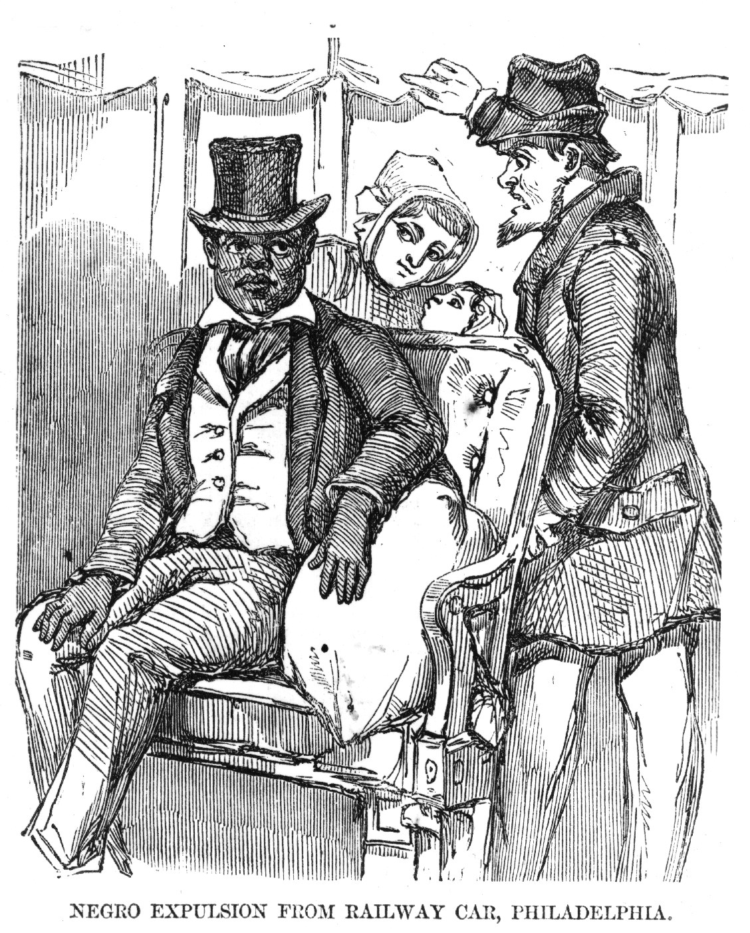
In 1890 a new Louisiana law required railroads to provide “equal but separate accommodations for the white, and colored, races.” Outraged, the black community in New Orleans decided to test the rule. On June 7, 1892, Homer Plessy agreed to be arrested for refusing to move from a seat reserved for whites. From this case comes the doctrine “separate by equal.”
“We consider the underlying fallacy of the plaintiff's argument to consist in the assumption that the enforced separation of the two races stamps the colored race with a badge of inferiority....The argument also assumes that social prejudices may be overcome by legislation, and that equal rights cannot be secured to the Negro except by an enforced commingling of the two races....
Legislation is powerless to eradicate racial instincts or to abolish distinctions based upon physical differences, and the attempt to do so can only result in accentuating the difficulties of the present situation. If the civil and political rights of both races be equal one cannot be inferior to the other civilly or politically. If one race be inferior to the other socially, the Constitution of the United States cannot put them upon the same plane.”

Justice John Harlan's dissent in Plessy, 1896
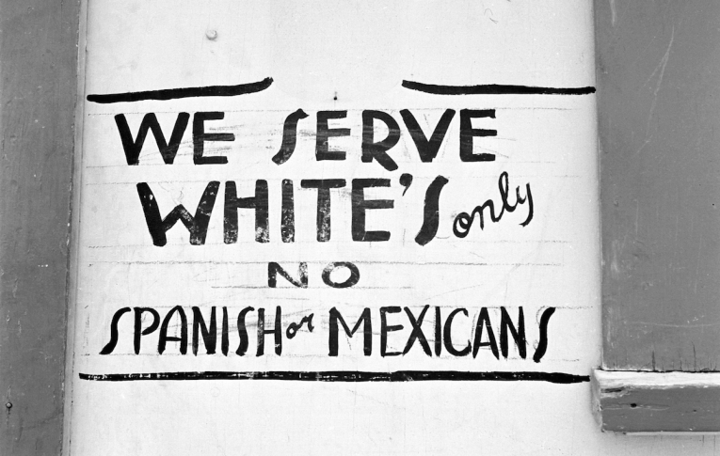
The white race deems itself to be the dominant race in this country....But in view of the Constitution...there is in this country no superior, dominant, ruling class of citizens. There is no caste here. Our Constitution is color-blind, and neither knows nor tolerates classes among citizens. In respects of civil rights, all citizens are equal before the law.

B. DeFacto Segregation
THE BLOG
07/24/2014 05:26 pm ET | Updated Sep 23, 2014

The Jim Crow North? Dining in New York City Before the Civil Rights Act of 1964
By Chin Jou
In the 1950s, a U.S. civil rights organization set out to investigate restaurant discrimination. As part of this effort, the organization interviewed an African-American man who related his experiences:
Every time I’m downtown I see invisible signs on the door of every restaurant, saying “Negroes, Keep out!” I make up my mind to have a good meal, and I walk for blocks, looking at every eating place I see, and wondering...And then I get cold feet and end up at a cafeteria - or else get a sandwich in a drug store.
This un-named man was not relating his experiences in Greensboro, Birmingham, or any other familiar southern flashpoint of the mid-20th century civil rights struggle. He was describing everyday life in New York City.
That New York City was segregated was not lost on contemporaneous observers. A June 2, 1963 article in The New York Times declared that, “segregation is as much a fact of life [in the North] as it is in the South.” According to The Times, “almost invariably the color of [“the Negro’s”] skin determines where he goes for school and how he makes his living.”
Under a 1952 anti-bias law, New Yorkers could report discrimination directly to the State Commission against Discrimination. (Previously, local district attorney’s offices — some of which were not exactly vigorous in pursuing discrimination complaints — had to first file suit against offending parties.) Those in violation of the 1952 law could be punished by having their names published and being issued cease and desist orders.
Made up of an interracial coalition of volunteers, the Committee on Civil Rights in East Manhattan (CCREM) deployed one hundred 53 of its members to 62 Manhattan restaurants to determine whether restaurant staff would treat African-American and white diners differently. The CCREM’s volunteer restaurant testers were divided into same-sex or opposite-sex pairs, including “minority teams” of black diners and “control teams” of white customers. According to CCREM literature, all testers “were of pleasing appearance, quiet in manner, and well, but not ostentatiously, dressed”; most were also educated professionals instructed to be as inconspicuous as possible while undercover. Immediately after dining, all testers recalled the restaurant service they had received by filling out the CCREM’s surveys.
In contrast to the South, where African-Americans were denied service at even casual establishments into the early 1960s, all of the CCREM’s African-American testers were served in 1950. That was the “good” news. Forty-two percent of the black testers did, however, discern varying degrees of racial bias from restaurant staff, with upscale establishments being more likely to dole out discriminatory service than modest dining spots. Meanwhile, none of the white testers reported discrimination at any of the restaurants.
The discrimination to which African-Americans were subjected took many forms. The CCREM’s surveys revealed that when its black testers first entered some restaurants, there was “evidence of confusion at the appearance of the Negro team or of hesitation about admitting them, such as a hasty conference between headwaiter and waiter, [and] shifting of waiters.” (Whether offending restaurant staff included people of color as hosts and servers is unknown.)
African-American restaurant patrons were then led into what the CCREM called “undesirable” seating arrangements — near kitchens, swinging doors, bathrooms, in back corners, on balconies, or other areas where they would be separate and out-of-sight from the majority of other diners. Describing her experiences with her fellow African-American dining companion, volunteer tester Olivia Pleasants Frost recounted being “taken to seats in the back of the restaurant behind a partition used to stack supplies, right beside the kitchen, while the control [white] team was allowed to select their own seats since the restaurant was only half full.”

